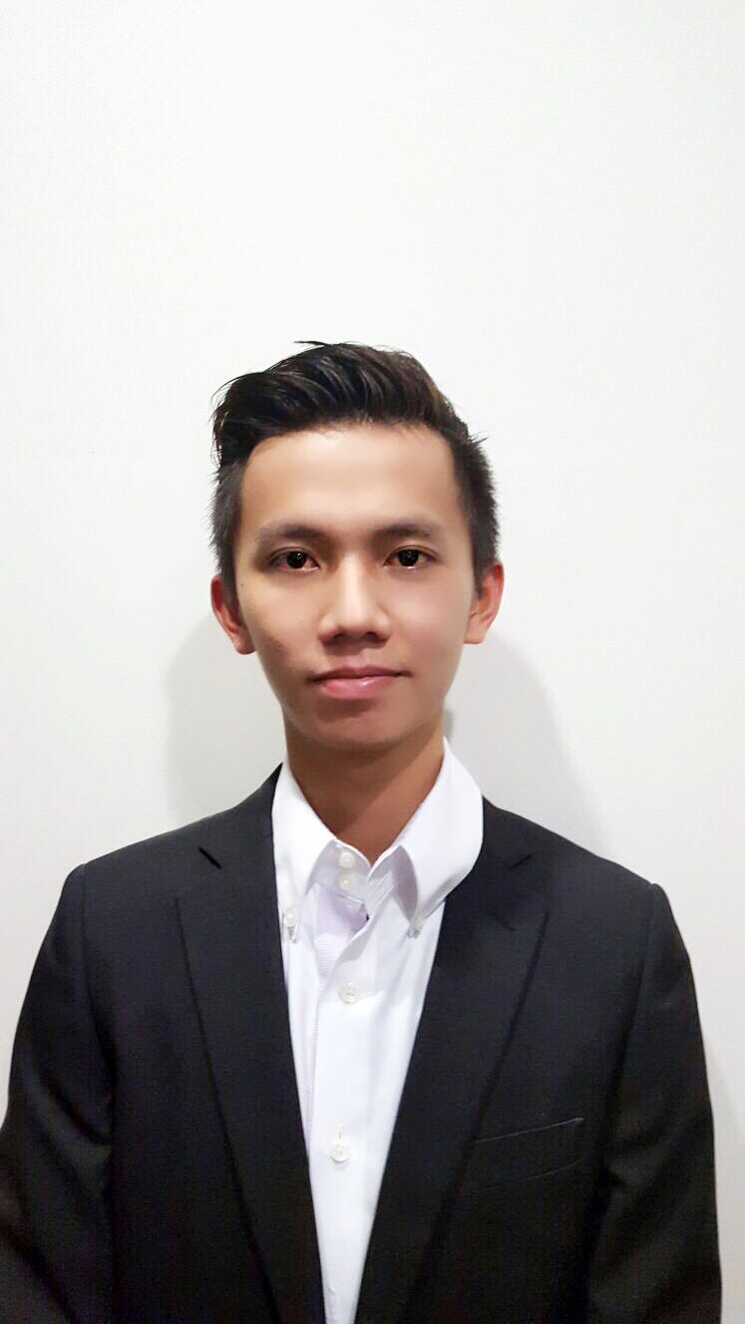

LIM JIA HAO   
61 #10-01 Tampines Ave 1 S529776  
+65 91872188 | limjiahao.tp@gmail.com

A versatile individual focused and determined to build a successful career.

• Very positive working attitude

• Team player with strong initiative

• Skilled in dealing with people from diverse backgrounds

• Strong capacity to learn and a thirst for knowledge

• Strong interpersonal and communications skills

• Exposed to many leadership roles

• Pleasant disposition and personality

**WORK EXPERIENCE**

|  |  |
| --- | --- |
| **Full Time**  **UniCredit Bank**  *FXMM Operations Staff*   * To ensure timely and accurate processing of all: * Foreign Exchange (FX) and Money Market (MM) transactions for the Asia Pacific Region (APR) and * The shared processing for FX Single Name Trading (SNT), FX and MM for UCB London and Milan interbank trades (TOM) * To ensure confirmations are properly matched in Intellimatch and payments are triggered prior to the currencies cut off time. For non SWIFT counterparties, to prepare and perform manual confirmation matching. * To perform Investigation on non-reconciled items and follow up on confirmation tracers. * To prepare and send weekly ageing reports to Management.   **National Service**  *Naval Combat System Operator (Republic of Singapore Navy)*   * Developed the ability to work well with teams * Developed a sense of critical thinking and problem solving   **Internship at SBA Stone Forest, Shanghai, China**  *Intern*   * Gained exposure to working in a Mandarin dominated environment * Responsible for accounts and audit preparation * Learned to prepare accounts using KingDee software | Current  ‘  Oct 2012 – Aug 2014  Sep 2011 – Jan 2012 |
| **Temp/Part-Time Jobs**  **Grain**  *Delivery Staff*   * *Responsible for delivery of meals island-wide* * *Developed a strong sense of punctuality*   **Radlink-Asia Pte Ltd**  *Accounts Assistant (Temp)*   * Responsible for assisting preparation of monthly accounts * Enhanced proficiency in use of Microsoft Excel | Mar 2016 – July 2016  Mar 2012 – Jun 2012 |

**EDUCATION**

|  |  |
| --- | --- |
| **Murdoch University**  Bachelor of Commerce, Double Major in Accounting & Finance  Awards   1. Vice Chancellor’s Commendation for Academic Excellence 2015 2. University Medalist 2016 ( Top 7 Annual Graduate ) 3. Valedictorian of March 2017 Graduation Ceremony   **GPA: 3.75/4.0**  **Temasek Polytechnic**  Diploma in Accounting and Finance  **GPA: 3.11/4.00**  **Chung Cheng High School (Main)**  GCE ‘O’ Level  **L1R5: 9 points**  **L1R4: 6 points** | Sep 2014 - Apr 2016    Apr 2009 – Apr 2012  Jan 2005 – Dec 2008 |

**CCA Achievements**

**Table Tennis**

• Captain of Chung Cheng High School (Main) Table Tennis 2005 – 2008

• National Inter-School Table Tennis 1st place 2006

• National Inter-School Table Tennis 1st Runner-up 2008

• East Zone Inter-School Table Tennis 1st place 2006 – 2008

**SKILLS, INTERESTS & OTHERS**

**Languages:** Fluent in English and Mandarin, written and spoken

**IT Skills:** Proficient in Microsoft Word, Excel and PowerPoint

**Interests:** Football, Darts, Table Tennis, Cycling and Socializing.

**Pes Status:** B

**Expected Salary:** SGD$3300 (Negotiable)